5 X Motor Assembly

Vitamins
36 Washer M3 x 7mm x 0.5mm  1 GT2 pulley 20 teeth  2 LM8UU bearings  1 NEMA17 x 47mm stepper motor  2 Nut M3  4 M3 cap screw x 18mm  2 M3 cap screw x 12mm | 2 No2 pan wood screw x 13mm  2 Washer M2.5 x 5.9mm x 0.5mm  1 Microswitch  1 M5 Brass nut  1 Nyloc nut M3

Printed parts
1 i3xends_v2_Motor  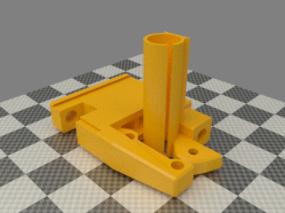 | 1 xendstop_45mm.stl  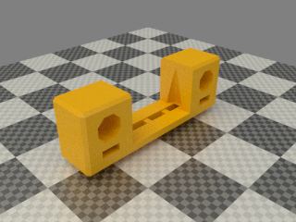 | 1 z_screw_isolator_right.stl  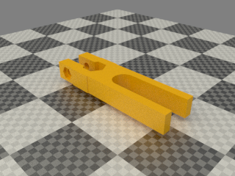

Assembly

- Slide the 2 motor parts together, they are a VERY tight fit. Don’t worry if they don’t slide completely together. When inserting the X rods they will home the last bit.
- Attach the stepper with the wires facing down. Use enough washers that the base of the stepper clears the inside of the motor mount plus 1mm.
- Slide on the pulley on and center it in the motor mount channel with a 1mm gap to the base of the stepper.
TIP: The goal is that the pulley can sit centered in the belt channel. You might need to add 1 more washer on each of the 3 screws for the motor
- Insert 2 LM8UU bearings, one from the top and one from the bottom.
- Insert 2 M3 nuts in the endstop and insert 2 M3 screws and washers
- Attach the microswitch with the wood screws and washers
- Insert a M5 brass nut in the isolator. Put a M3 nut and washer through the isolator and a M3 Nyloc on the other side.
- Bundle up motor wires.

